As on 19th October 2021
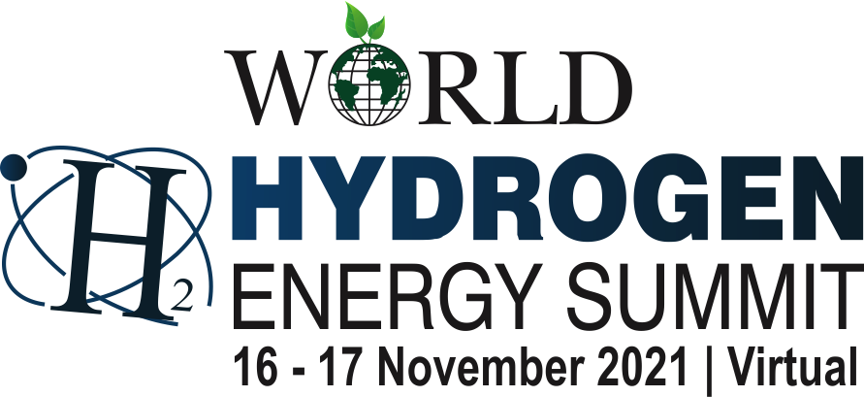

THEME:
Green Hydrogen: Cleaner and Zero Emission Fuel for a Sustainable Green Economy
Programme
FIRST DAY
Tuesday, 16th November 2021

09h45 onwards Assembly

10h00 – 11h30 Inaugural Session [HALL-I]

Welcome Address by
Dr. N. B. Mazumdar
Chairman, International Academy of Environmental Sanitation and Public Health

Address by
Dr. Stephan Hesselmann
Economic Minister Counsellor, Embassy of Germany

Theme Address by
Mr. Anil Razdan
Former Secretary Power, Government of India
Chairman, Energy And Environment Foundation

Industry Address by
Mr. Nobuo Tanaka
Special Advisor, The Sasakawa Peace Foundation
Former Executive Director, International Energy Agency, Japan

Address by the Guest-of-Honour
Dr. Noe van Hulst, Chair, International Partnership for Hydrogen and Fuel Cells in the Economy

H.E. Mr. Hans Jacob Frydenlund
Ambassador of the Norway, Royal Norwegian Embassy

H.E. Mr. Marten van den Berg
Ambassador of the Netherlands, Embassy of The Netherlands

H.E. Mr. André Aranha Corrêa do Lago
Ambassador of the Brazil, Embassy of Brazil

Release of Background Paper

Award Distributions by the Chief Guest
The EEF Global Excellence Award 2021
HYDROGEN / WASTE MANAGEMENT SECTOR
Inaugural Address by the Chief Guest
Mr. R. K Singh
Hon'ble Union Cabinet Minister of New and Renewable Energy & Power, Government of India*

Vote of Thanks by
Dr. Anil K Garg
President, World Hydrogen Energy Summit
11h30 – 12h00 — Networking Break for Tea / Coffee —

12h00 – 13h30 Plenary Session – I [HALL-I]
Hydrogen from Renewables for a Sustainable Future
Chair
Mr. Anil Razdan
Former Secretary Power, Government of India & Chairman, Energy And Environment Foundation

Key Speaker
Mr. Geoffrey Drucker, Managing Director, Countrywide Renewable Hydrogen Limited, Australia
Dr. SSV Ramakumar, Director (R&D), Indian Oil Corporation Limited
Mr. Alok Nanda, CEO, GE John F. Welch Technology Center
Mr. Jan Deman, Managing Director, Busworld Academy, Belgium
Ms. Martina Steinkusz, Director of Market Development, Renewable Hydrogen Alliance, USA
Mr. Kostiantyn Gura, Chair of UNECE Bureau of Experts on Renewable Energy, Ukraine
Dr. Bibek Bandyopadhyay, Senior Adviser, Strategy & Transactions, Ernst & Young Services

13h30 – 14h00 — Networking Break for Lunch —

14h00 – 15h30 Plenary Session – II [HALL-I]
Hydrogen Fuel Cell Solutions
Chair

Key Speaker
Mr. Mark Kirby, President & Chief Executive Officer
Canadian Hydrogen and Fuel Cell Association, Canada
Mr. Rami Reshef, CEO, GenCell Energy, Israel
Mr. Jack Hedge, Executive Director, Utah Inland Port Authority, USA

15h30 – 16h00 — Networking Break for Tea / Coffee —

16h00 – 17h30 Plenary Session – III [HALL-I]
Hydrogen: Heavy Transportation and Mobility
Chair

Key Speaker
Mr. Paul Nillesen, Partner, PwC Strategy , The Netherlands
Mr. Michael Dolman, Partner, Element Energy, UK
Mr. Reine Alemar, Director Transport Development, Volvo Trucks, Sweden
Mr. Matthew Blieske, Chief Executive Officer, LIFTE ^{H2}, USA
Mr. Nikolas Iwan, Managing Director, H2 MOBILITY Deutschland GmbH & Co KG, Germany

17h30 – 18h00 — Networking Break for Tea / Coffee —

18h00 – 19h30 Plenary Session – IV [HALL-I]
Hydrogen and Green Energy Transition

Chair & Moderator
Mr. Sebastian Koks Andreassen, CEO, Green Hydrogen Systems, Denmark

Key Speaker
Mr. Jose Ignacio Sanz Saiz, India Country Chairman & Managing Director, TotalEnergies Gas & Power
Mr. Cristian Valdes Carter, Director of Innovation Norway in India
Mr. Frank Wouters, Senior Vice President – Energy Transition, Reliance Industries Limited
Chairman, MENA Hydrogen Alliance, Abu Dhabi
Ms. Louise Sengeløv, Co-Founder & Green Hydrogen Expert, Peak Element, Denmark
Mr. Andreas Guth, Policy Director, Eurogas, Belgium
Mr. Ali Zerouali, Cooperation and International Business Development Director, Masen
Moroccan Agency for Sustainable Energy, Morocco
Ms. Alicia Eastman, President, InterContinental Energy, UK

SECOND DAY
Wednesday, 17th November 2021

10h00 – 11h30 The EEF Global Award 2021 Ceremony [HALL-I]
Welcome Address by
Dr. Anil Garg, President, World Hydrogen Summit 2021

Address by
Mr. Anil Razdan, Former Secretary Power, Govt. of India &
Chairman, Energy And Environment Foundation
Special Keynote Address by
Dr. John W. Sheffield, Professor of Engineering Technology, Purdue University, USA

Address by the Guest-of-Honour
Mr. Durga Shanker Mishra, Secretary, Ministry of Housing and Urban Affairs, Government of India

Award Distributions Ceremony
The EEF Global Hydrogen Awards 2021
The EEF Global Waste Management Awards 2021

11h30 – 12h00 — Networking Break for Lunch —

12h00 – 13h30 Keynote Session – V [HALL-I]
Green Hydrogen: Storage, Rail Transport and Sustainable Aviation Fuel
Chair

Key Speaker
Ms. Sanne Weekers, Business Development Manager, LAVO, Australia
Dr. Christoph Pasternak, Executive Director, Sector Head Rail & Bus
Bayerische Landesbank, Germany
Dr. Naveed Akhtar, Founder and CEO, Hy-Hybrid Energy, UK
Dr. Val Miftakhov, Founder & CEO, ZeroAvia, UK
13h30 – 14h00 — Networking Break for Lunch —

14h00 – 15h30 Keynote Session – VI [HALL-I]
International Cooperation: Financing Green Hydrogen Projects

Chair
Key Speaker
Ms. Martina Wettin, Co-Founder, Board Member & Chief Business Development Officer
Nilsson Energy, Sweden
Mr. Thomas Engelmann, Head of Energy Transition
KGAL Investment Management GmbH & Co. KG, Germany
Mr. Ravin Mirchandani, Executive Chairman, Ador Powertron
Dr. Martin Lux, Head of Energy Team-India, KfW Development Bank

15h30 – 16h00 — Networking Break for Tea / Coffee —

16h00 – 17h30 Keynote Session – VII [HALL-I]
Green Hydrogen through Electrolysis of Water and
Safety of Hydrogen in the Energy Systems

Chair
Mr. Werner Diwald, Chairman of the Board, The German Hydrogen and Fuel Cell Association
(DWV) Germany
Key Speaker
Mr. Matthew Blieske, Chief Executive Officer, LIFTE ^{H2}, USA
Mr. Sebastian Koks Andreassen, CEO, Green Hydrogen Systems, Denmark
Dr. Indrajit Shown, Professor, Department of Chemistry, Centre for Clean Energy and Nano Convergence
Hindustan Institute of Technology and Science

17h30 – 18h00 — Networking Break for Tea / Coffee —

18h00 – 19h30 Keynote Session – VIII [HALL-I]
Low Carbon Resources: Unlocking the Hydrogen Economy

Chair
Ms. Fernanda Delgado, Professor and Researcher, FGV Energia, Brazil

Key Speaker
Ms. Neva Espinoza, Vice President, Energy Supply and Low-Carbon Resources,
Electric Power Research Institute, USA
Ms. Stefanie Petersb, CEO, Neuman & Esser Group, Germany
Mr. Venkat Venkataraman, CTO & Executive VP Engineering, Bloomenergy, USA

19h30 – 19h40 Vote of Thanks

